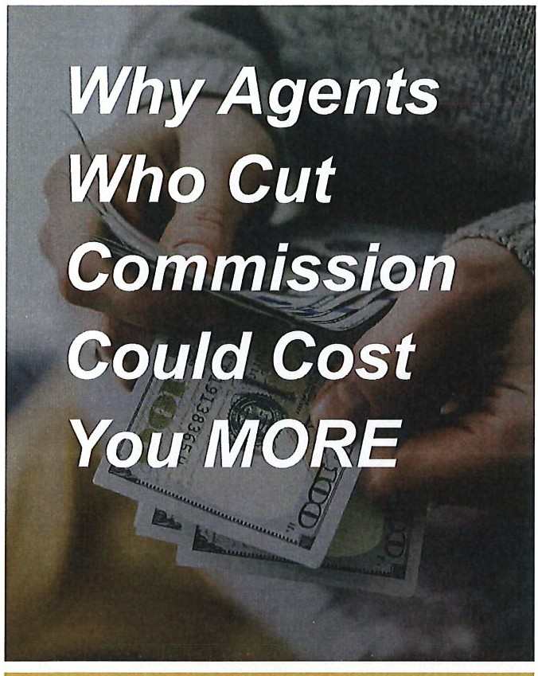

Six Reasons Why Real Estate Agents May Reduce Their Commission, and Why It Could Cost You Plenty!

1. **They need the business.** In today's competitive market some agents are offering to cut their commissions because they don't have systems in place to find buyers. They want to be listing agents. There is a difference in wanting your business and needing your business. Do you really want to trust someone who is desperate for your business?
2. **They don't have a marketing system that works.** If your property doesn't sell, what have you accomplished? There is a difference between listing a property and selling a property. What the other agent didn't tell you is that they will make less money selling your property than if they sell another property on the market. You want an agent who is going to be excited about bringing you an offer.
3. **If they cut their commission then they will have to cut service.** Which services are they going to cut? Many factors come into play in finding the right buyer that is willing to pay your price. To get top dollar for a property you need as many services going for you as you can possibly get.
4. **A 1**% **reduction in commission equals over 15% of the total commission.** Would you really be excited about a 15% pay cut? How can the other agent really be excited about working for you? Is that other agent being honest with you when they say they're excited about getting your property sold?

(insert picture, logo, contact info, & disclaimer here.)

1. **Are they going to cooperate with other brokers?** What are they going to pay those brokers? Why are those brokers going to be excited about a 15% pay cut? To get top dollar for your property you need to have all the brokers in your marketplace excited about selling your property.
2. **To get top price for your property you need a skilled negotiator working for you.** If that other broker is willing to let you negotiate them out of 15% or more of their income from the sale price of your property, will they also let the buyer negotiate 15% or more from the purchase price of your property? What is that other broker's sale price to list price ratio? You might be costing yourself tens of thousands of dollars trying to save a couple thousand dollars in commissions.

Before you commit to an agent, be sure a cut in commission makes sense for your family's bottom line.